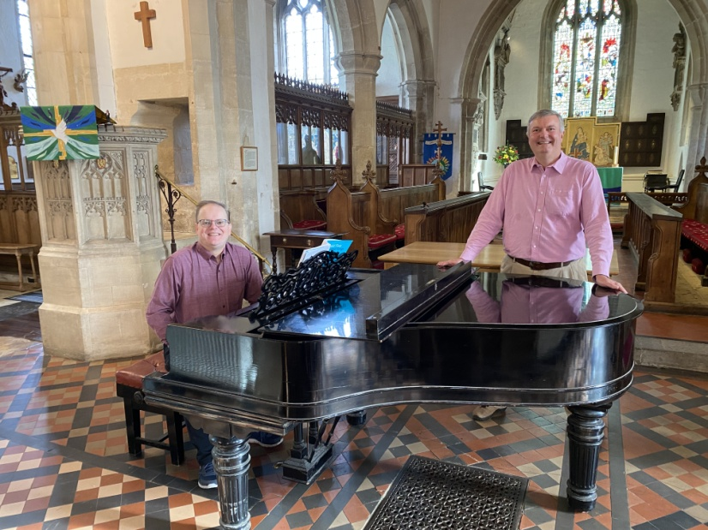

Chris Hall and Robert Burgess

Welcome to the first of our new series of Sunday afternoon concerts.

Our next concert is on Sunday 18 February at 4pm featuring Nigel Davies (organ).

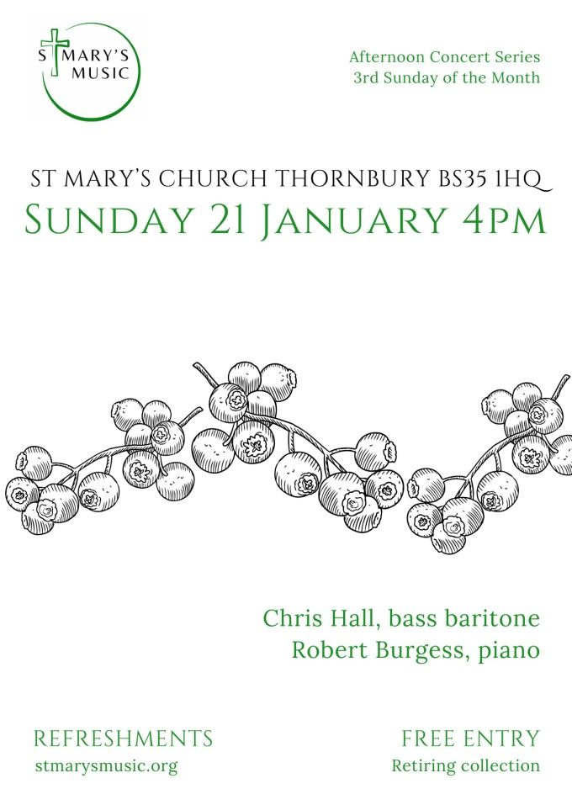

**PROGRAMME**

**Gustav Holst (1874-1934)**:

The Sergeant’s Song (Thomas Hardy)

**Ralph Vaughan Williams (1872-1958)**:

Songs of Travel (Robert Louis Stevenson)

1 The Vagabond

2 Let beauty awake

3 The Roadside Fire

4 Youth and Love

5 In dreams

6 The infinite shining heavens

7 Whither must I wander?

8 Bright is the ring of words

9 I have trod the upward and the downward slope

**Frédéric Chopin (1810-1849)**:

Nocturne in C# minor

**Gerald Finzi (1901-1956)**:

The Clock of the Years (Thomas Hardy)

**Franz Schubert (1797-1828)**:

Who is Sylvia (in English) (William Shakespeare)

**Gerald Finzi (1901-1956)**:

Who is Sylvia (William Shakespeare)

O Mistress Mine (William Shakespeare)

It was a lover and his lass (William Shakespeare)

Rollicum Rorum (Thomas Hardy)

**Chris Hall**has had the thrill and privilege of singing as a soloist under the direction of Gavin Carr (with whom he is studying), Emma Kirkby, Robert Hollingworth, Christopher Finch and Brian Kay, in England, Estonia, Germany, Italy and Peru.  Work includes Christus in the St Matthew Passion, the Brahms and Fauré Requiems, and a growing recital repertoire.  He lives in Randwick.

**Robert Burgess**began playing the piano at the age of four and was immediately captivated.  By the time he left school, he was a Grade 8 pianist with many performances under his belt.  After university, he went on to study accompaniment under Eugene Asti at Trinity College of Music in London. Performances have included the Schumann Dichterliebe, Cezar Franck Violin Sonata in A, Schubert’s Shepherd on the Rock and the Haydn Cello Concerto in C.  Robert has twice won the Cheltenham Festival Open Piano Solo competition.